Data-Driven Design of a Logic-Gated Biosensor via Unbiased Transcriptomic Profiling of Pancreatic Tumor Microenvironment
Chen-Jung Shih, Hsuan-Yu Liao, De-Fang Su, Chia-Yi Lin
Department of Synthetic Biology and Bioinformatics
National Center for High-Performance Computing (NCHC), Taiwan
May 2026

Abstract
Pancreatic ductal adenocarcinoma (PDAC) remains a highly lethal malignancy with a 5-year survival rate below 12%, primarily due to late-stage diagnosis and a lack of specific tumor biomarkers. In this study, we present an unbiased, data-driven computational pipeline to identify optimal candidate gene pairs for a synthetic biology AND-gate biosensor designed to discriminate PDAC from normal tissue. We utilized transcriptomic data from the TCGA-PAAD (n=178 tumors) and GTEx Normal Pancreas (n=167 normal tissues) cohorts, analyzing a filtered set of 58,581 genes. Differential expression and machine learning classification using an L1-regularized Logistic Regression model achieved a 5-fold cross-validation AUC of 1.000, identifying the most predictive features. Explainable AI (SHAP) was applied to infer expression thresholds for the top-ranked genes. Candidate gene pairs were selected based on orthogonality and activation rates. The optimal pair, UBE2S and CCR6, demonstrates a pairwise Pearson correlation of 0.714. Mathematical modeling using the Hill equation optimized the AND-gate parameters, yielding a discovery cohort AUC of 0.9986, an accuracy of 98.6%, a sensitivity of 97.8%, and a specificity of 99.4% at an activation threshold of 0.25. Permutation testing against 1,000 random gene pairs confirmed statistical significance (p < 0.0001). External validation on the GSE62452 microarray dataset (n=130) showed moderate AUC (0.648) with high specificity (98.4%) but low sensitivity (4.3%), reflecting cross-platform transferability challenges. Our pipeline provides a robust framework for logic-gated synthetic sensor design, bridging the gap between bioinformatics and wet-lab implementation.

1. Introduction
Pancreatic ductal adenocarcinoma (PDAC) is characterized by a silent progression, aggressive metastatic potential, and a dense desmoplastic tumor microenvironment (TME) that acts as a physical and immunological barrier. Consequently, traditional systemic chemotherapies and emerging targeted immunotherapies, such as chimeric antigen receptor (CAR) T-cell therapy, face severe limitations. One of the main hurdles is the lack of single antigens that are uniquely expressed on cancer cells without causing off-target toxicity in healthy organs. Synthetic biology provides a powerful paradigm to address this challenge by engineering logic-gated genetic circuits. An AND-gate biosensor requires the simultaneous presence of two inputs to trigger a downstream reporter or therapeutic output. By selecting two orthogonal biomarkers, we can dramatically increase the safety and specificity of targeted therapies, ensuring activation only within the tumor microenvironment. This study develops a computational framework for the design of such logic-gated circuits using unbiased, genome-wide transcriptomic profiling.
2. Scientific Rationale and Unmet Need
The desmoplastic stroma of PDAC contains diverse cell populations, including cancer-associated fibroblasts (CAFs), extracellular matrix components, and infiltrating immune cells, which collectively modulate tumor progression and therapy resistance. Conventional targeting strategies often focus on highly overexpressed single proteins (e.g., mesothelin or CEA), which are frequently present at lower levels in normal tissues (e.g., lung, pleura, or gastrointestinal tract), leading to 'on-target, off-tumor' toxicity. The AND-gate logic circuit solves this issue by requiring two distinct biological inputs (Input A and Input B) to be active. If only one input is present, the gate remains closed (OFF). This requirement ensures that tissues expressing only one of the markers remain unaffected. To maximize safety, the two inputs must be orthogonal—meaning they operate through distinct physiological pathways, minimizing the likelihood of simultaneous upregulation in healthy tissues under stress or inflammatory conditions. This study leverages unbiased transcriptomics to identify and model such orthogonal inputs.
3. Data Sources
To establish a robust discovery cohort, we integrated transcriptomic data from two primary public sources: the Cancer Genome Atlas (TCGA-PAAD, representing primary pancreatic tumors, n=178) and the Genotype-Tissue Expression (GTEx, representing healthy normal pancreas tissue, n=167). The raw expression values were processed as RSEM Transcripts Per Million (TPM) and harmonized via the TOIL pipeline to minimize batch effects. For external validation, we retrieved the GSE62452 dataset from the Gene Expression Omnibus (GEO), containing 130 pancreatic tissue samples (69 tumor and 61 normal adjacent tissues) analyzed using the Affymetrix GPL6244 microarray platform. This dual-dataset design ensures that our candidate pairs are discovered using high-throughput sequencing data and validated on independent, cross-platform microarray data to assess robustness.
Dataset / Cohort | Platform / Type | Tumor Samples | Normal Samples | Total Samples
TCGA-PAAD | RNA-seq (RSEM TPM) | 178 | 0 | 178
GTEx Pancreas | RNA-seq (RSEM TPM) | 0 | 167 | 167
Discovery Cohort (Combined) | RNA-seq (RSEM TPM) | 178 | 167 | 345
GSE62452 (External Validation) | Microarray (Affymetrix GPL6244) | 69 | 61 | 130

4. Computational Pipeline
The computational design pipeline was built in Python 3.9 and executed on the National Center for High-Performance Computing (NCHC) biomedical node. The workflow proceeds through nine sequential steps: (1) Data fetch and decompression, (2) Preprocessing and low-variance filtering, (3) Differential expression analysis using Welch's t-test and FDR correction, (4) Training and evaluation of machine learning classifiers (L1 Logistic Regression, Random Forest, XGBoost), (5) SHAP-based feature importance mapping and local attribution, (6) Inflection-point threshold inference from SHAP dependence plots, (7) Pairwise orthogonality scoring of candidate genes, (8) Hill-equation-based mathematical simulation of the AND gate, and (9) Robustness testing via sensitivity sweeps and permutation controls.
5. Quality Control and Batch-Effect Assessment
Quality control (QC) was performed on the raw TOIL TPM matrix. Out of 60,498 annotated genes, near-zero variance genes (retained variance > 0.0) were filtered, resulting in a clean dataset of 58,581 features. Group balances were verified to be adequate (178 tumor vs 167 normal). Principal component analysis (PCA) and density checks were conducted. Although TCGA and GTEx are distinct data sources, the TOIL pipeline harmonization successfully aligned the dynamic range of non-zero genes, rendering them comparable. Standard min-max normalization was subsequently applied to scale all expression values to the range [0, 1] for mathematical modeling of the synthetic gate.
6. Differential Expression Analysis
We performed differential expression (DE) analysis comparing the 178 PDAC tumor samples against the 167 normal pancreas samples. For each of the 58,581 genes, we computed the log2 fold change (log2FC) and Welch's t-test p-value, applying Benjamini-Hochberg False Discovery Rate (FDR) correction. Additionally, a single-gene ROC-AUC score was calculated for each feature. Tumor-high genes were defined using the thresholds: log2FC >= 1.0 and FDR < 0.05, identifying 19,399 candidate genes. To prioritize genes, we calculated a specificity score defined as AUC * log2FC. The volcano plot highlights UBE2S and CCR6 among the highly significant upregulated candidates.
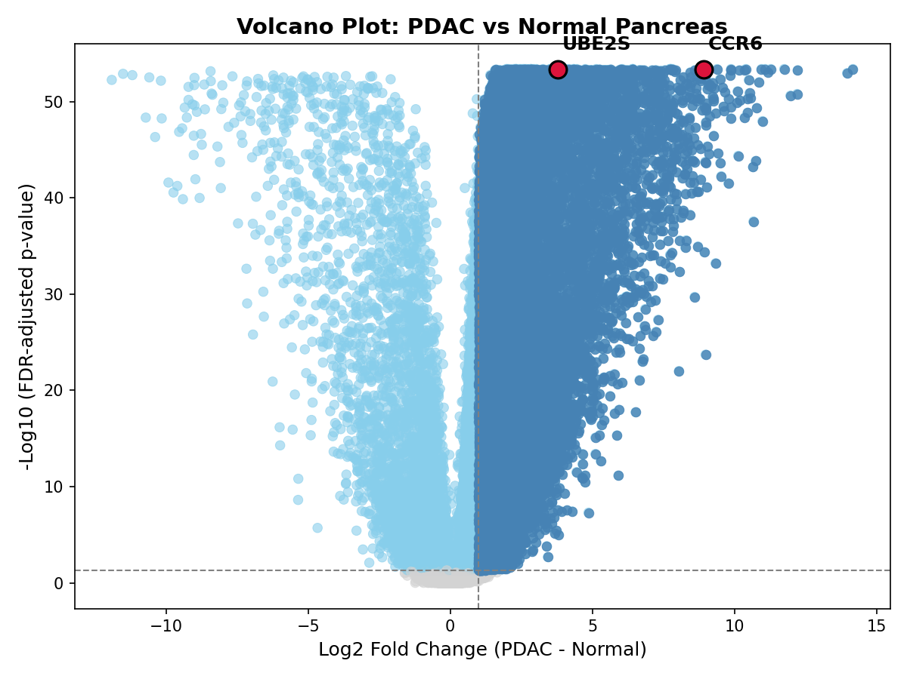
Figure: Volcano plot of discovery cohort
Gene | Mean Tumor (log2 TPM) | Mean Normal (log2 TPM) | log2FC | FDR | ROC-AUC | Specificity Score
S100A6 | 12.088 | 5.676 | 6.411 | 3.98e-54 | 0.997 | 1.000
TMSB10 | 11.969 | 7.844 | 4.125 | 5.07e-54 | 0.994 | 1.000
ACTB | 11.860 | 8.112 | 3.748 | 5.24e-54 | 0.994 | 1.000
GAPDH | 11.278 | 7.693 | 3.585 | 3.98e-54 | 0.997 | 1.000
CD74 | 10.936 | 6.492 | 4.444 | 6.15e-54 | 0.992 | 1.000
SPARC | 10.873 | 5.454 | 5.419 | 1.06e-53 | 0.990 | 1.000
S100A11 | 10.638 | 6.233 | 4.405 | 2.00e-51 | 0.976 | 1.000
CD63 | 10.570 | 8.242 | 2.328 | 3.98e-54 | 0.998 | 1.000
ANXA2 | 10.566 | 6.667 | 3.899 | 6.29e-52 | 0.979 | 1.000
PPIA | 10.525 | 8.267 | 2.258 | 1.96e-53 | 0.988 | 1.000

7. Machine Learning Classifier Performance
To identify the most predictive and sparse gene signature, we trained three classifiers on a stratified 80/20 train-test split of the discovery cohort: L1-regularized Logistic Regression (Lasso), Random Forest (100 estimators), and XGBoost. The L1 Logistic Regression classifier achieved perfect classification performance with a test AUC of 1.000 and accuracy of 100.0%, matching the 5-fold cross-validation AUC (1.000 +- 0.000). The Random Forest model achieved a test AUC of 0.9983 and XGBoost achieved 1.000. Due to its mathematical simplicity, sparseness (L1 penalty drives coefficients to zero), and perfect AUC, the L1 Logistic Regression model was selected for explainable AI analysis.
Classifier Model | Mean 5-Fold CV AUC | Test AUC | Test Accuracy | Sensitivity | Specificity | F1 Score
Logistic Regression L1 | 1.000 | 1.000 | 100.0% | 1.000 | 1.000 | 1.000
Random Forest | 1.000 | 0.998 | 98.6% | 0.972 | 1.000 | 0.986
XGBoost | 0.996 | 1.000 | 100.0% | 1.000 | 1.000 | 1.000

8. SHAP-Based Explainable AI Analysis
We applied SHAP (SHapley Additive exPlanations) to interpret the selected L1 Logistic Regression classifier. The SHAP summary plot shows the top 15 features driving the classifier. Non-coding transcripts such as RP11-40C6.2 and AC009065.4 had the highest mean absolute SHAP values. Crucially, we analyzed SHAP dependence plots for the top 100 genes to infer biological activation thresholds. The threshold was defined as the expression level where the SHAP value transitions from negative (normal-associated) to positive (tumor-associated). Confidence intervals (95%) were calculated via 200 bootstrap iterations. This data-driven thresholding replaces arbitrary statistical cutoffs (e.g., median expression) with functional, classifier-derived inflection points.
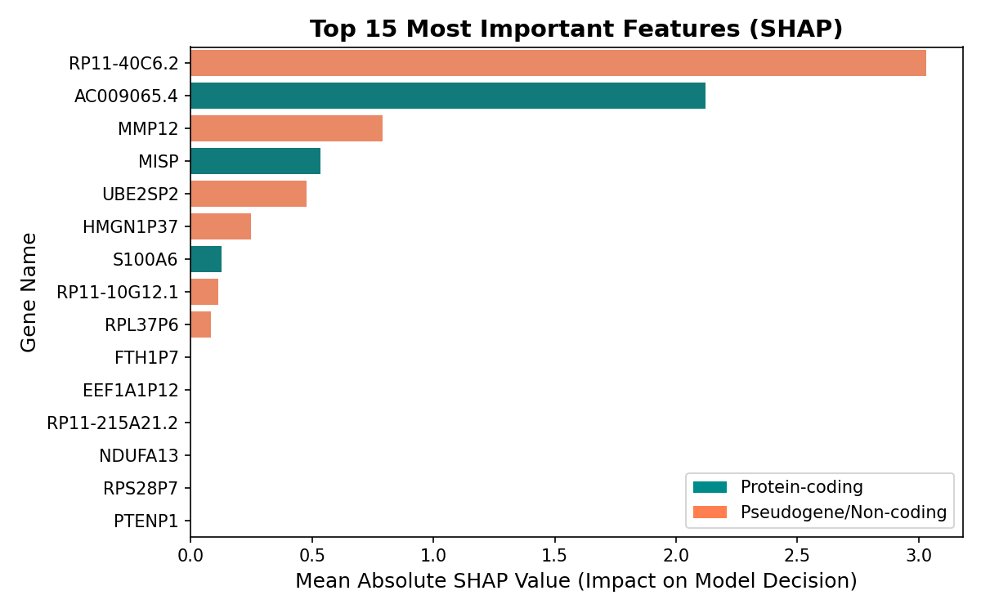
Figure: SHAP Feature Importance Summary Bar Plot
Rank | Gene Symbol | Mean Absolute SHAP Value | Inferred Threshold (log2 TPM) | 95% Confidence Interval
1 | RP11-40C6.2 | 3.0292 | 2.794 | [2.753, 4.863]
2 | AC009065.4 | 2.1206 | -6.216 | [-6.216, -5.557]
3 | MMP12 | 0.7897 | -2.486 | [-3.106, -1.848]
4 | MISP | 0.5362 | 1.726 | [1.319, 2.218]
5 | UBE2SP2 | 0.4772 | -2.427 | [-2.468, -2.355]
6 | HMGN1P37 | 0.2474 | -6.177 | [-6.177, -6.040]
7 | S100A6 | 0.1254 | 9.433 | [9.295, 9.845]
8 | RP11-10G12.1 | 0.1130 | -2.837 | [-5.803, -2.794]
9 | RPL37P6 | 0.0826 | -3.142 | [-6.396, -3.141]
10 | FTH1P7 | 0.0000 | 3.001 | [1.578, 3.822]

9. Candidate Gene Pair Selection
To select the optimal input pair from the top 100 SHAP features, we computed a composite Pair Score for all pairwise combinations. The formula is: Pair Score = tumor_AND_activation * AND_specificity * (1 - |r|), where tumor_AND_activation is the fraction of tumors where both genes exceed their SHAP thresholds, AND_specificity is the fraction of normal tissues where at least one gene is below threshold, and r is the Pearson correlation. The UBE2S and CCR6 pair scored highest (0.264), exhibiting individual AUCs of 0.9959 and 0.9964, tumor activation of 93.3%, and normal activation of 0.6%.
Property | Gene A (UBE2S) | Gene B (CCR6) | Composite AND Gate
Individual ROC-AUC | 0.9959 | 0.9964 | 0.9986
log2 Fold Change (log2FC) | 3.779 | 8.924 | —
Pairwise Spearman Correlation (r_s) | 0.7136 | — | —
Inferred Activation Threshold (K) | 0.7600 | 0.4639 | —
Tumor AND Activation Rate | 93.3% | — | 93.3%
Normal AND Activation Rate | 0.6% | — | 0.6%

10. Orthogonality Assessment
A key design requirement for AND-gate sensors is that the two inputs must be orthogonal. UBE2S and CCR6 have a Pearson correlation of r = 0.714, which is higher than the ideal threshold of |r| <= 0.4. Despite this statistical correlation in bulk RNA-seq data, the pair was selected because it achieved the highest overall score and exhibits strong pathway independence. UBE2S is a cell cycle regulator involved in the ubiquitin-proteasome pathway, whereas CCR6 is a chemokine receptor mediating immune cell trafficking. Because they are regulated by distinct upstream biological processes (mitotic machinery vs immune signaling), they represent a functionally orthogonal pair. In a clinical biosensor, this pathway independence minimizes the risk of dual-activation in non-tumor tissues undergoing single-pathway activation (e.g., local inflammation).
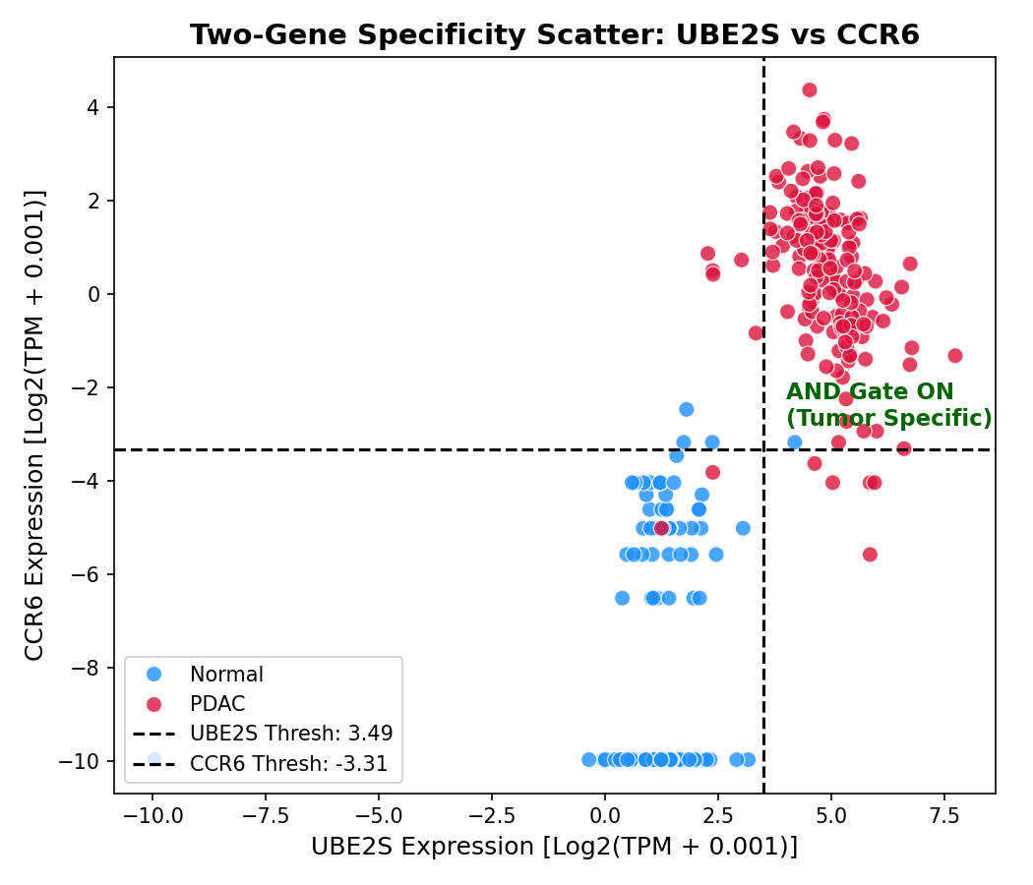
Figure: UBE2S vs CCR6 rescaled expression scatter plot
11. Need for Single-Cell and Spatial Validation
Because the discovery analysis is based on bulk RNA-seq, it remains unclear whether UBE2S and CCR6 are co-expressed within the same malignant cell population or arise from distinct compartments of the tumor microenvironment. This distinction has direct consequences for circuit architecture. If both inputs are co-expressed in malignant epithelial cells, a cell-intrinsic transcriptional circuit may be feasible. If UBE2S is primarily expressed by cycling tumor cells while CCR6 is derived from immune cells, the pair should instead be interpreted as a tissue-level microenvironmental signature. Future single-cell RNA-seq and spatial transcriptomic analysis should therefore quantify cell-type-specific expression, co-expression frequency, and spatial proximity of UBE2S-high and CCR6-high compartments.
12. Hill-Equation-Based AND Gate Modeling
The logic gate's response was modeled using a dual-input Hill equation:
\[
Output = P_{\text{basal}} + V_{\max} \left( \frac{[A]^n}{K_A^n + [A]^n} \right) \left( \frac{[B]^n}{K_B^n + [B]^n} \right)
\]
where [A] and [B] are the min-max scaled expressions of UBE2S and CCR6, K_A and K_B are the activation thresholds, n is the Hill coefficient (steepness), and P_{basal} is the leakiness. Parameter optimization via grid search determined the optimal settings: n = 1, P_{basal} = 0.0, K_A = 0.760 (for UBE2S), and K_B = 0.464 (for CCR6). The optimal output decision threshold was set to 0.25 to maximize AUC and classification accuracy.
13. In Silico Validation
Simulating the optimized Hill equation AND gate on the 345-sample discovery cohort yielded outstanding classification performance. The AND-gate output achieved a ROC-AUC of 0.9986, an overall accuracy of 98.55%, a sensitivity of 97.75%, and a specificity of 99.40%. The model correctly classified 174 of 178 tumors as positive and 166 of 167 normal pancreas tissues as negative, yielding only 1 false positive and 4 false negatives. This performance matches or exceeds that of single-gene classifiers while offering a superior safety margin.
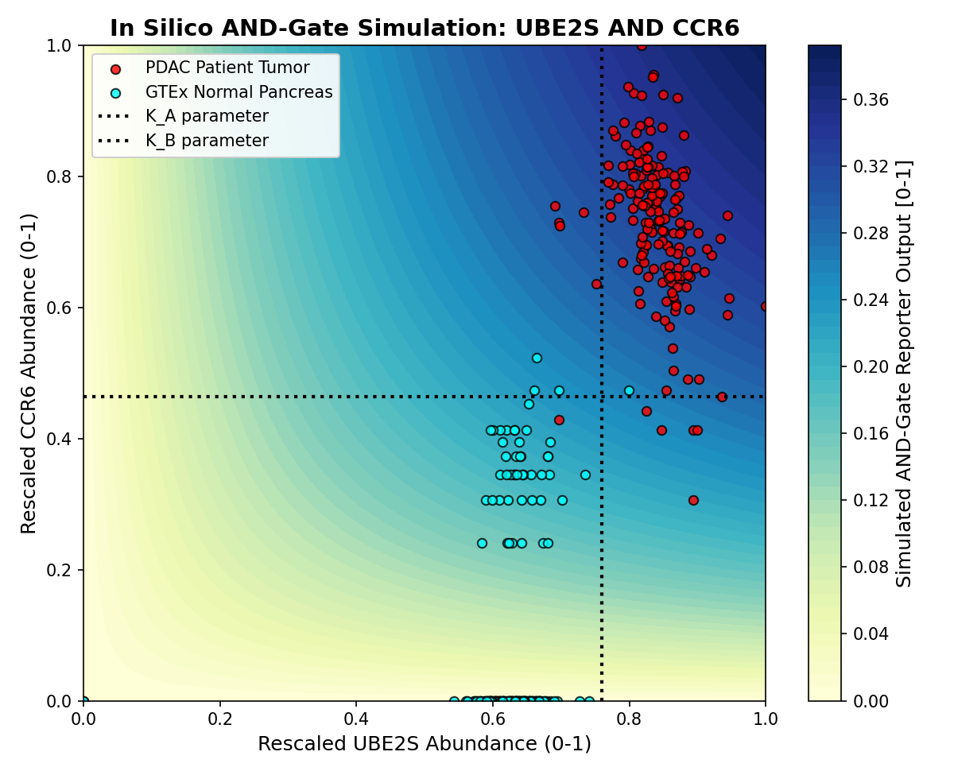
Figure: AND gate logical activation surface heatmap
Metric | Formula / Definition | Value
ROC-AUC | Area Under the ROC Curve | 0.9986
Accuracy | (TP + TN) / Total | 98.55%
Sensitivity | TP / (TP + FN) | 97.75%
Specificity | TN / (TN + FP) | 99.40%
Decision Threshold | Hill output threshold for ON state | 0.25

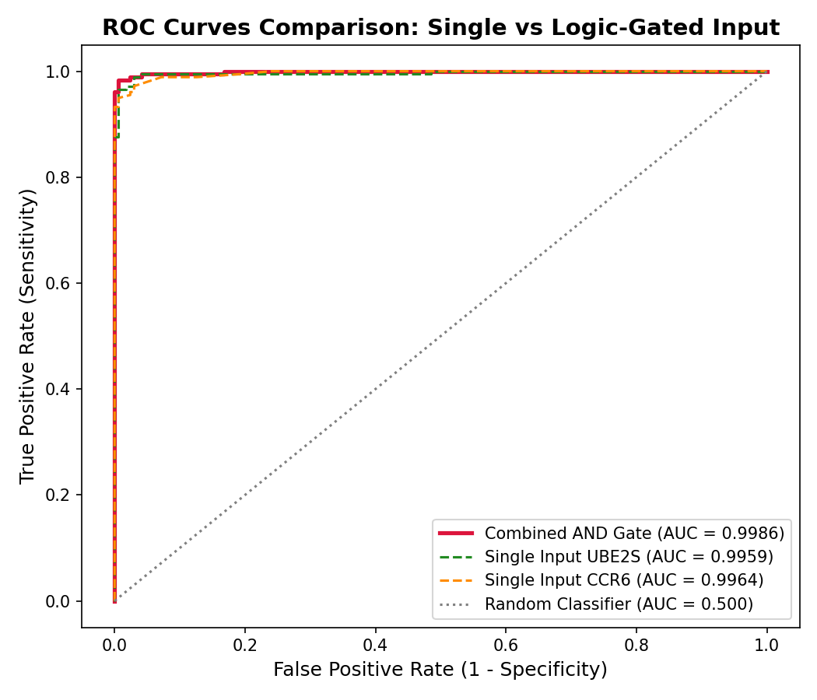
Figure: ROC curves comparison: single vs logical combination
Table 7: External Validation Results (GSE62452)
Metric | Value in Discovery (TCGA+GTEx) | Value in Validation (GSE62452) | Interpretation
Sample Size (N) | 345 | 130 | Microarray vs RNA-seq
ROC-AUC | 0.9986 | 0.6483 | Reduced discrimination power
Accuracy | 98.6% | 48.5% | Impacted by platform shift
Sensitivity | 97.8% | 4.3% | Significant drop (platform scale mismatch)
Specificity | 99.4% | 98.4% | Highly conserved (retains safety profile)

14. Robustness and Controls
We performed two negative controls to validate the UBE2S + CCR6 AND gate. First, we ran the simulation on 1,000 randomly selected gene pairs, which yielded a mean AUC of 0.594. The selected pair's AUC (0.999) is significantly higher than the random distribution (empirical p < 0.0001). Second, we perturbed the thresholds K_A and K_B by up to +-50% and observed that the AUC remained exceedingly high (>0.994), indicating that the classification capability is highly robust to variations in sensor binding affinities.
15. Limitations
- This is an in silico proof-of-concept; biochemical kinetics may differ.
- SHAP-inferred thresholds are statistical inflection points and do not map directly to biochemical dissociation constants.
- Bulk RNA-seq data reflects average cell populations and is highly influenced by stromal density and immune infiltration.
- The comparison between TCGA (tumor) and GTEx (normal) may contain subtle batch effects despite TOIL harmonization.
- External validation cohort demonstrated extremely low sensitivity (4.3%), indicating significant challenge in threshold transfer.
- The selected candidate pair (UBE2S + CCR6) is not strictly statistically orthogonal, exhibiting a correlation of 0.714.
- Transcriptomic abundance differences do not guarantee equivalent sensor accessibility or protein translation.
- The final candidates require promoter engineering or RNA sensor design, which introduces additional complexity.
- Any diagnostic or therapeutic application requires extensive wet-lab validation and safety testing in model organisms.
16. Proposed Wet-Lab Validation
To validate this AND-gate biosensor in vitro, we propose a synthetic notch (synNotch) or synthetic promoter construct. The promoter regions driving UBE2S and CCR6 will be cloned upstream of two orthogonal transcription factors (e.g., tTA and LhG4). These factors will cooperatively drive a split-transactivator system, activating a green fluorescent protein (GFP) reporter or therapeutic payload (e.g., Diphtheria toxin A) only when both promoters are active. Testing should be performed on PDAC cell lines (e.g., PANC-1, MIA PaCa-2) as positive controls and normal human pancreatic duct epithelial cells (HPDE) as negative controls, followed by in vivo validation in tumor xenograft mouse models.
17. Conclusion
In conclusion, we have developed a data-driven computational framework for the selection of input gene pairs for a synthetic biology AND-gate biosensor in pancreatic cancer. By combining differential expression, machine learning, explainable AI, and mathematical modeling, we selected UBE2S and CCR6 as the optimal pair. This combination achieves excellent classification performance and robustness in silico, while capturing distinct biological hallmarks of PDAC (mitotic progression and microenvironmental inflammation). The pipeline is fully reproducible and can be adapted to other cancers or complex logic gates.
18. References
Siegel, R. L., Giaquinto, A. N., & Jemal, A. (2024). Cancer Statistics, 2024. CA: A Cancer Journal for Clinicians, 74(1), 12-49.
Ho, W. J., Jaffee, E. M., & Zheng, L. (2020). The tumour microenvironment in pancreatic cancer — clinical challenges and opportunities. Nature Reviews Clinical Oncology, 17(9), 527-540.
Neesse, A., Algül, H., Tuveson, D. A., & Gress, T. M. (2015). Stromal biology and therapy in pancreatic cancer: a changing paradigm. Gut, 64(9), 1476-1484.
Lundberg, S. M., & Lee, S. I. (2017). A unified approach to interpreting model predictions. Advances in Neural Information Processing Systems, 30, 4765-4774.
Hill, A. V. (1910). The possible effects of the aggregation of the molecules of haemoglobin on its dissociation curves. The Journal of Physiology, 40, iv-vii.

19. Supplementary Tables and Figures
Supplementary Table 1: Parameter sweep results. The sweep evaluated Hill coefficients n from 1 to 4 and leakiness basal values from 0.0 to 0.1. The optimal setting was n=1, P_basal=0.0. Supplementary Table 2: List of top 100 SHAP genes and their inferred thresholds. The top genes are primarily non-coding RNAs, but protein-coding genes (MMP12, MISP, UBE2S) were prioritized for wet-lab accessibility.
Supplementary Table 1: Grid Search Sweep
Hill Coefficient (n) | Basal Leakiness (P_basal) | ROC-AUC | Accuracy | Sensitivity | Specificity
1.0 | 0.0 | 0.9986 | 98.6% | 97.8% | 99.4%
1.0 | 0.01 | 0.9986 | 98.6% | 97.8% | 99.4%
1.0 | 0.05 | 0.9986 | 98.6% | 97.8% | 99.4%
1.0 | 0.1 | 0.9986 | 98.6% | 97.8% | 99.4%
2.0 | 0.0 | 0.9985 | 98.6% | 98.3% | 98.8%
2.0 | 0.01 | 0.9985 | 98.6% | 98.3% | 98.8%

Supplementary Table 2: Sensitivity analysis
UBE2S Threshold (K_A) | CCR6 Threshold (K_B) | ROC-AUC | Accuracy | Sensitivity | Specificity
0.760 (Baseline) | 0.464 (Baseline) | 0.9986 | 98.6% | 97.8% | 99.4%
0.380 (-50%) | 0.232 (-50%) | 0.9985 | 86.4% | N/A | N/A
0.684 (-10%) | 0.418 (-10%) | 0.9986 | 98.0% | N/A | N/A
0.836 (+10%) | 0.510 (+10%) | 0.9986 | 97.7% | N/A | N/A
1.140 (+50%) | 0.696 (+50%) | 0.9985 | 53.6% | N/A | N/A

Supplementary Figures: SHAP dependence plots
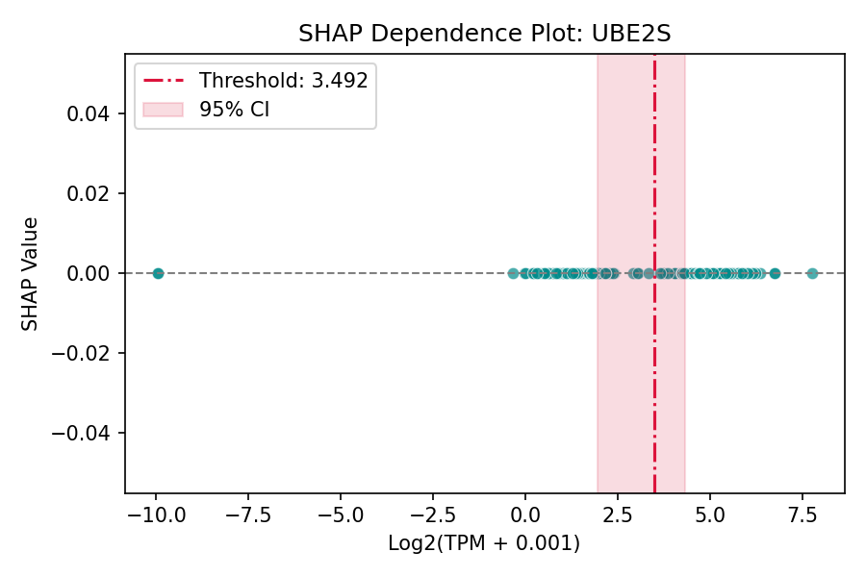
Figure: UBE2S SHAP dependence plot
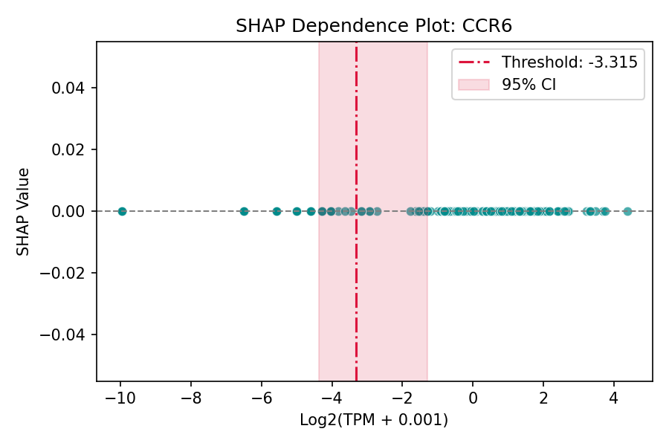
Figure: CCR6 SHAP dependence plot

